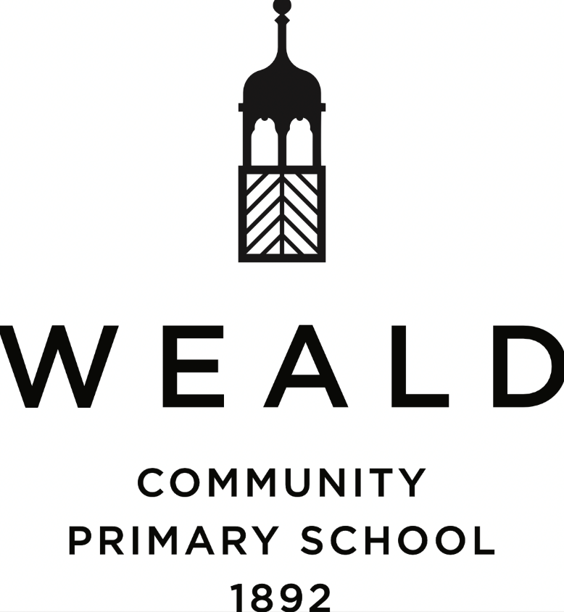

Curriculum Statement

Date written: September 2026

Date of next review: September 2027

"In our school, we smile, share, and shine together. Through character development we learn to think for ourselves, help each other, and grow into kind, confident people. Everyone belongs, everyone matters, and together we make our school a happy place to be."
It is our belief that every pupil who enters our school community should be valued and nurtured, challenged and inspired. Underpinning the development of the curriculum are the philosophical approaches and practices of Character Education.
We aim to develop individuals, through good teaching and encouragement, to reach their full potential academically, socially and emotionally against the background of a broad, balanced and differentiated curriculum. In all school activities, we aim to promote independence, respect for learning, consideration for others, and self-esteem.
We recognise that every child has a different knowledge base and skill set, as well as varying aptitudes and aspirations; and that, as a result, there is a determination for every child’s needs to be assessed and their talents developed through diverse teaching strategies. Therefore, we seek to develop the full potential of every pupil outside the classroom in physical, creative, and cultural pursuits, including new technology.

The curriculum offered at Weald Community Primary School is broad, balanced and challenging. It is designed to give a good grounding from the Early Years, not only in reading, writing and mathematics but also in science, design technology, art, computing, geography, history, MFL, RE and the creative arts. We consider PE, sport, outdoor learning, drama, music & dance as critical components of creativity, teamwork and the building of character qualities such as fortitude, communication and sense of fair play.
Curricular content is based upon the National Curriculum, particularly with respect to reading, writing, numeracy and science.

Curriculum aims

Through personalisation of the educational offer, we strive to match learning tasks to appropriate levels of ability and attainment so that all children can gain a sense of achievement and pleasure from their learning.

We aim to support our children by:

- Use language and numbers effectively and with understanding;
- Develop a critical understanding and respect for the environment and world in which they live and an awareness of the interdependence of individuals, groups and nations;
- Develop lively, enquiring minds, the ability to ask questions, solve problems, argue rationally and apply themselves to tasks;
- Develop self-awareness, a sense of self-respect, and a willingness to be self-motivated and contribute to the school community and the wider society;
- Develop a respect for other people, acknowledging that the differences in their abilities, background, and beliefs bring richness into our own lives;
- Gain pleasure from joining with others in games and outdoor activities and develop the social skills needed to live and work co-operatively.
Implementation of curriculum aims.

The class teachers will be responsible for the broad spread of teaching at Key Stage One and Two; however, the school operates a specialist teaching model which seeks to enrich learning through the utilisation of teachers’ and teaching assistants’ areas of interest, knowledge, experience and skill.

Within this framework, our aims are fulfilled in the following ways:
• All children embrace the challenge of reading and writing in different genres and continue to build their confidence in speaking and listening activities.
• From the acquisition of key skills, we encourage our children to develop as active learners with lively and enquiring minds, the ability to ask questions, solve problems, argue rationally, and apply themselves to tasks.
• Increasingly, computing is employed in our teaching and learning across the school.
• In the wider world, the environment, human achievements and aspirations, self-awareness and self-motivation and awareness of others feature significantly through the teaching of Geography, Science, History, PSHE and RE.
• The teaching of Modern Foreign Languages is an integral part of our curriculum.
• Passion for the Arts is also developed through our teaching of Music, Dance and Art.
• There is a strong emphasis on PE & sport, enabling all children to enjoy participation in a wide range of individual and team sports. A full programme of sporting competition is available to children.

Curriculum planning

To be effective, teaching and learning must be planned and sequential.
Planning incorporates EYFS, the National Curriculum and Character Education.
Children take the National Curriculum SATs tests at the end of Key Stage Two.

Reception follows the DfE Curriculum Guidance for the Early Years Foundation Stage:
- Communication & language;
- Physical development;
- Personal, social & emotional development;
- Literacy;
- Mathematics;
- Understanding the world;
- Expressive arts & design.

From Year One to Year Six, the curriculum consists of the National Curriculum; each subject has a policy, action plan and progression document which outlines the intent, implementation and impact of the programmes of study and at what stage. These are amplified through each year group’s medium-term plans (published six times per year).

From Foundation Stage through to Year 6, opportunities will be taken to extend the curriculum beyond the statutory requirements through:
• visitors, including artists, authors, actors, musicians; scientists etc
• the use of the school grounds, the locality and the wider environment
• educational visits including residential trips from Year 3 upwards.;
• support of parents.
Many of these activities will embrace the cultural diversity of the society in which we live and enhance the aesthetic environment of the school.

Coverage & time allocation

Currently, each lesson is approximately one hour in length, and the expected provision is as follows:

Maths X 5 incl. Mental Maths & Timestables
English X 5 incl., Writing & SPaG
Reading X 2
Science X 2
Geography/History X 2
PSHE/Character X 1
RE X 1
Modern Foreign Languages X 1
PE/Sport X 2
Music X 1
Art/DT X 1
Computing X 1
Forest School/Outdoor Learning X 1

The curriculum coverage and allocation of time for the delivery of the various subjects is an on-going developmental process and the overall balance will be reviewed each year and adjusted according to children’s needs.

Reviewed: September 2026

To be reviewed: September 2027

