Venus - Term 6 Creative Curriculum: Why do so many people in the world live in megacities? 2025/2026
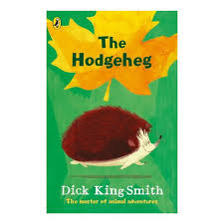
SPaG:

- Adverbs
- Conjunctions
- Nouns and pronouns
- Apostrophes
- Verb tenses
- Direct speech

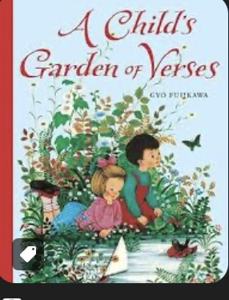
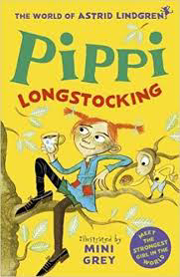
Computing:
Programming B – Events and actions in programs
- Explore the links between events and actions, while consolidating prior learning relating to sequencing
- Move a sprite in four directions (up, down, left and right)
  - Explore movement within the context of a
maze, using design to choose an
appropriately sized sprite
    - Learn about programming extensions
through the use of pen blocks
    - Draw lines with sprites, and change the colour and size of lines
    - Designing and coding their own programs
R.E:

- How do family life and festivals show what matters to Jewish people.

Literacy: Class Reading Book: Pippi Longstocking by Astrid Lindgren

Fiction
Modern Fiction
Enjoy Dick King-Smith’s The Hodgeheg. Explore plot, character and dialogue. Study speech
punctuation and adverbs for time, place and manner. Write a new animal adventure.
Poetry
Classic Poems: A Child’s Garden of Verses by Robert Louis Stevenson
This wonderful collection loses none of its power to excite, enthuse and inspire
by being immersed in these classic timeless poems. Study verbs, tense and extend sentences.

Science:

- Plants (requirements for life and growth, naming and function of parts)
- Flowers, fruits, pollination and seeds.
Topic: History enquiry – Why do so many people in the world live in megacities?

- This investigation supports the children to develop their understanding of the important geographical concepts of settlement and urbanisation through the study of the world’s megacities (cities with a
population of over 10 million). Over half the world’s population now live in towns and cities.
- The children will explore some of the economic and social reasons why the population of cities
increase. They will compare and contrast the benefits and problems of housing people at such high densities.
Application of skills & processes:
Recognise Identify Describe Empathise Synthesise Explain Apply
Observe Select Categorise Evaluate Reach informed conclusions Hypothesise
Classify Sequence Compare & contrast Make reasoned judgements. Justify
Recall Summarise Reason/speculate Demonstrate understanding Critique

Art/DT:

- DT: design and make cards with moving parts
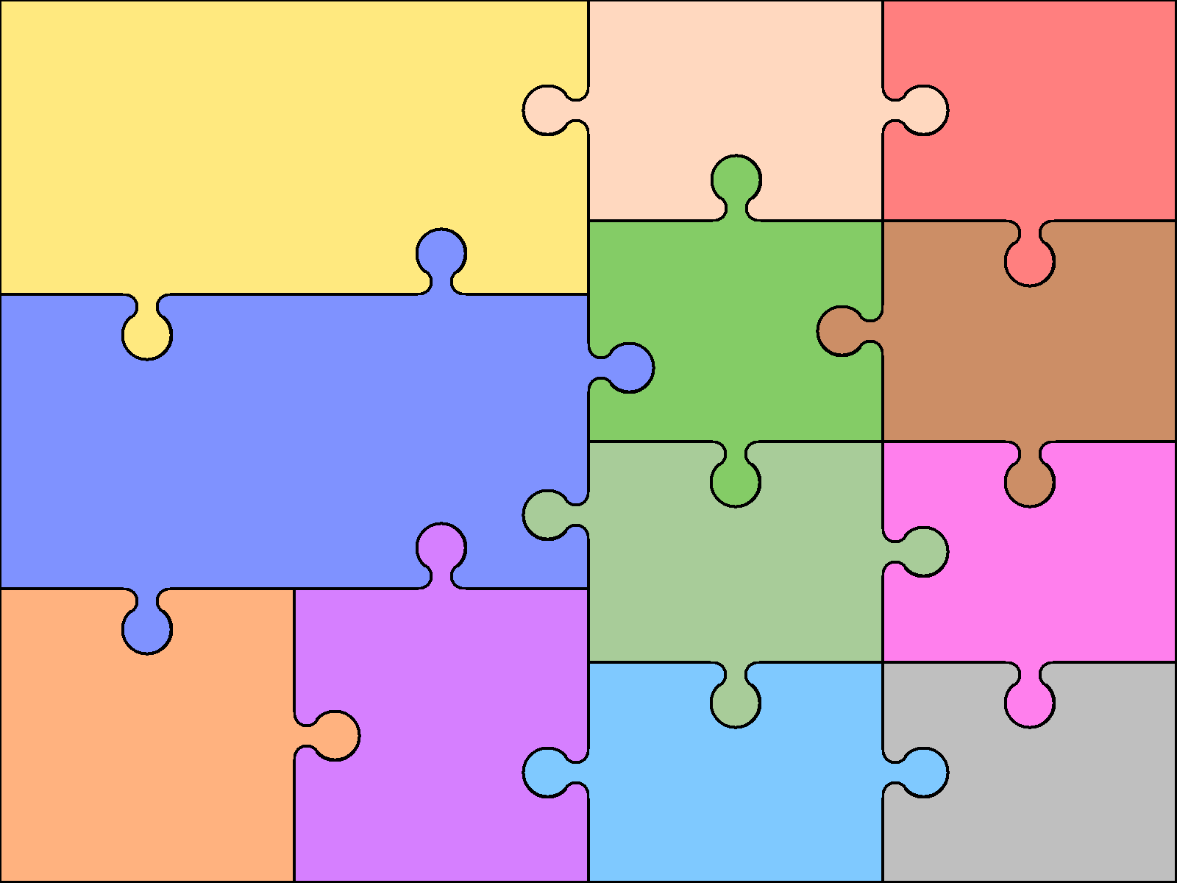  Numeracy:  Measurement - Money  - Add and subtract money  - Find change  Geometry - Shape  - Turns and angles, right angles and compare angles  - Measure and draw accurately  - Horizontal, vertical, parallel and perpendicular  - Recognise and describe 2-D and 3-D shapes  - Draw polygons and make 3-D shapes  Statistics  - Interpret and draw pictograms and bar charts  - Collect and present data, and two-way tables  Measurement - Time  - Roman numerals  - Tell the time to the minute and five minutes  - Read time on a digital clock and use a.m. and p.m.  - Days & hours, hours & minutes, minutes & seconds |  |  | Numeracy - Reasoning  Reasoning is the catalyst for the teaching of maths. A key skill in becoming fully numerate (and to becoming an independent thinker) is the ability to make your own decisions and learn from them.  This key skill is central to the children’s math’s learning and a chance to allow learners to  choose their own methods and ways of recording,  then present their findings in whichever way they decide. Learners are encouraged to explain their reasoning, thus extending the understanding and their ability to communicate, numerically. | Languages: Spanish  - Zoo animals  - Animals and opinions  - Sentence building | Music:  Reflect, rewind. and replay  - Listen and appraise Classical music  - Continue to embed the foundations of the interrelated dimensions of music using voices and instruments  - Singing  - Play instruments within the song  - Improvisation using voices and instruments  Physical Education:  Athletics:  - Developing skills  Tennis:  Develop knowledge and skills of Netwall sports

