Badgers - Term 1. Creative Curriculum: How did a pile of dragon bones help to solve an ancient Chinese mystery? 2026/2027
SPaG:
- Adverbs of possibility
- Commas
- Relative clauses
- Pronouns
- Dialogue punctuation
- Proper nouns
- Possessive plural apostrophes
- Past & present. progressive and present perfect. tenses

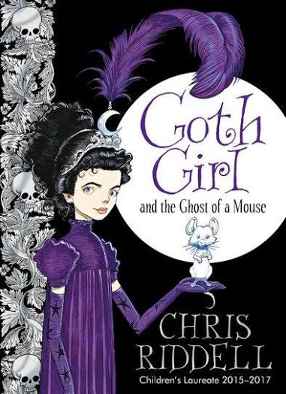
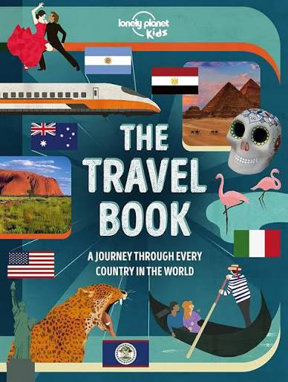
Computing:
Computing systems and networks – systems and searching
- Develop understanding or computer systems and how information is transferred between systems and devices.
- Consider small and large scale systems
  - Explain the input, output and process
aspects of a variety of different
real-world systems.
    - Discover how information is found
on the World Wide Web through learning how search engines work (including how they select and rank results) and what influences searching, and through comparing different search engines.
R.E:

- Why do some people think that God exists?

Literacy:
Gothic Fiction
Through Chris Riddell’s Goth Girl and the Ghost of a Mouse the children will explore
how atmosphere, settings and character are created. The children will study adverbs
of possibility, commas, relative clauses and dialogue punctuation.
Non-fiction
Blogs and Reports: Travel writing
The children will explore exciting destinations through a range of travel writing.
They will revise pronouns, relative clauses and punctuation, including commas.

Science:

- Properties of materials: How to group them and their uses.
Topic: History enquiry – How did a pile of dragon bones help to solve an ancient Chinese mystery?
- An important objective of this enquiry is to understand that the vast majority of objects and inscriptions that the Shang left behind provide an insight only into the ways of life of a
tiny minority of people: the wealthy and most privileged.
- Another important aspect of this investigation is for the children to reflect upon the
qualities they feel a monarch needs to rule effectively.
- Shang society was one in which women in general possessed little status but nevertheless from within it emerged China’s first female warrior general.
Application of skills & processes:
Recognise Identify Describe Empathise Synthesise Explain Apply
Observe Select Categorise Evaluate Reach informed conclusions Hypothesise
Classify Sequence Compare & contrast Make reasoned judgements. Justify
Recall Summarise Reason/speculate Demonstrate understanding Critique

Art/DT:

- Art: Chinese mark making and dragon painting
  Numeracy:  Number – Place Value  - Roman numerals to. 1,000  - Numbers to 10,000, 100,000 and 1,000,000  - Powers of 10  - 10/100/1,000/10,000/100,000 more or less  - Partition numbers and number line to 1,000,000  - Compare and order numbers to 100,000 & 1,000,000  - Round to the nearest 10, 100 or 1,000  - Round within 100,000 and 1,000,000  Number – Addition and subtraction  - Add and subtract whole numbers with more than four digits  - Round to check answers  - Inverse operations (addition and subtraction)  - Multi-step addition and subtraction problems  - Compare calculations  - Find missing numbers |  |  | Numeracy - Reasoning  Reasoning is the catalyst for the teaching of maths. A key skill in becoming fully numerate (and to becoming an independent thinker) is the ability to make your own decisions and learn from them.  This key skill is central to the children’s math’s learning and a chance to allow learners to  choose their own methods and ways of recording,  then present their findings in whichever way they decide. Learners are encouraged to explain their reasoning, thus extending the understanding and their ability to communicate, numerically. | Languages: Spanish  - Greetings  - Where I live  - Phonics S & C  - Compass points | Music:  Livin’ on a prayer  - Listen and appraise the classic rock song Livin’ on a Prayer by Bon Jovi  - Learn to sing, play, improvise and compose with this song  - Also listen to and appraise other classic rock songs  Physical Education:  Invasion games:  - Hockey  Invasion games:  Basketball at Sevenoaks School

