Pupil premium strategy statement – Weald Community Primary School

This statement details our school’s use of pupil premium funding to help improve the attainment of our disadvantaged pupils.
It outlines our pupil premium strategy, how we intend to spend the funding in this academic year and the outcomes for disadvantaged pupils last academic year.

School overview
Detail | Data
Number of pupils in school | 100
Proportion (%) of pupil premium eligible pupils | 21%
Academic year/years that our current pupil premium strategy plan covers (3-year plans are recommended – you must still publish an updated statement each academic year) | 2024/2025 to 2026/2027
Date this statement was published
Date on which it will be reviewed | November 2025
Statement authorised by | Chris Taylor – Head Teacher
Pupil premium lead | Lisa Drogomirecki - SENCO
Governor / Trustee lead | Wendy Wallace-Holman

Funding overview
Detail | Amount
Pupil premium funding allocation this academic year | £31,815
Pupil premium funding carried forward from previous years (enter £0 if not applicable) | £0
Total budget for this academic year  If your school is an academy in a trust that pools this funding, state the amount available to your school this academic year | £31,815

Part A: Pupil premium strategy plan

Statement of intent
Weald Community Primary School is committed to ensuring that all pupils, regardless of background, have access to high-quality education and opportunities that enable them to thrive. Our Pupil Premium Strategy sets out our intent to close attainment gaps and support the academic and personal development of disadvantaged pupils.
Our core objective is for these pupils to achieve outcomes in line with national expectations, while developing key character traits such as resilience, independence, and curiosity. We believe that character education is fundamental to lifelong learning and success, and it is embedded throughout our curriculum and wider school life.
To achieve this, we focus on early identification of need, inclusive teaching, and targeted support. This includes structured phonics and language programmes, small group teaching where possible, and access to enrichment activities such as Forest School and educational visits. Practical support is also provided to remove barriers to learning.
Our strategy is underpinned by high expectations, timely intervention, and whole-school responsibility. All staff contribute to pupil progress, and decisions are guided by assessment rather than assumption. The strategy is reviewed annually to ensure it remains effective and responsive to pupil needs.

Challenges
This details the key challenges to achievement that we have identified among our disadvantaged pupils.
Challenge number | Detail of challenge
1 | Assessments and observations suggest disadvantaged children generally have greater difficulties with phonics than their peers. This negatively impacts their development as readers.
2 | Assessments, observations and communications with children indicate underdeveloped oral language skills and vocabulary gaps among many disadvantaged children. These are evident from Reception through to KS2 and in general are more prevalent among our disadvantaged pupils than their peers.
3 | Our observations and discussions with children and their families have identified social and emotional difficulties for many pupils. These challenges particularly affect disadvantaged children, impacting their attainment.
4 | There continues to be low attendance and persistent absenteeism of PP/ disadvantaged children. There needs to be more work with families around the important of attendance and support for those children who feel anxious around school.

Intended outcomes
This explains the outcomes we are aiming for by the end of our current strategy plan, and how we will measure whether they have been achieved.
Intended Outcome | Success Criteria
Enhanced oral language and vocabulary among disadvantaged pupils. | Improved oral language evidenced through assessments, observations, and engagement. Support includes structured observations, formal assessments, targeted interventions, and specialist referrals.
Improved reading attainment. | Over 50% of disadvantaged pupils to meet KS2 reading standards by 2026/27.This target is based on current national data showing that fewer than half of disadvantaged pupils currently achieve this benchmark. Setting the goal above 50% represents an ambitious yet realistic improvement aligned with national trends and government priorities to close the attainment gap. Progress tracked via provision meetings, targeted interventions, and consistent phonics and spelling instruction. Pupils supported with appropriate reading opportunities in school.
Improved maths attainment at KS2. | Over 50% of disadvantaged pupils to meet KS2 maths standards by 2026/27. This same 50% target reflects similar attainment patterns to the reading, where disadvantaged pupils consistently perform below the national average.
Improved wellbeing, especially for disadvantaged pupils. | High wellbeing levels shown through surveys, observations, and increased enrichment participation. Character development tracked via assessment tools and passports. Support provided through pastoral care, family services, and curriculum-based wellbeing initiatives.
Improved attendance, particularly among disadvantaged pupils. | Attendance monitored to reduce persistent absence and close gaps.  By 2026/27: unauthorised absence below 5%, attendance gap reduced by 10%, and persistent absence below 40%, with disadvantaged pupils no more than 20% behind peers.

Activity in this academic year
This details how we intend to spend our pupil premium funding this academic year to address the challenges listed above.
https://educationendowmentfoundation.org.uk/education-evidence/teaching-learning-toolkit

Teaching (for example, CPD, recruitment and retention)
Budgeted cost: £ 10,000
Activity | Evidence that supports this approach | Challenge number(s) addressed
Allocation of funds for reading, writing and maths initiatives, subscriptions and high quality texts for EYFS, KS1 and KS2. | Funding will be directed towards high-quality resources and subscriptions to strengthen reading, writing, and mathematics across EYFS, KS1, and KS2. This includes investment in high-quality texts and evidence-based programmes to support early language development and phonics. Quality First Teaching will remain the foundation of classroom practice, enhanced through ongoing CPD and the effective use of digital tools and subscriptions. These measures aim to ensure consistent, high-impact teaching and improved outcomes for all pupils, particularly those eligible for Pupil Premium.  https://www.gov.uk/government/publications/the-pupil-premium-how-schools-are-spending-the-funding-successfully  Phonics | Teaching and Learning Toolkit | EEF | 1,2
Allocation of funds towards Continuing Professional Development (CPD) for teachers and TAs across school. Impact of each CPD event to be recorded and monitored. | Funding will be directed towards high-quality CPD for teachers and teaching assistants across the school. Each CPD event will be evaluated for its impact on classroom practice and pupil outcomes, with monitoring systems in place to ensure effectiveness.  There is strong evidence from the Education Endowment Foundation (EEF) that developing teachers’ understanding of social and emotional learning (SEL) can significantly improve pupils’ academic performance, behaviour, and relationships. The EEF report Improving Social and Emotional Learning in Primary Schools highlights that well-trained staff are better equipped to embed SEL strategies into everyday teaching, supporting both attainment and wellbeing.  Improving_Social_and_Emotional_ Learning in Primary Schools | EEF | 1,2,3,4
Purchase of INSIGHT – an online tracking system for pupils. | The Education Endowment Foundation (EEF) recommends that schools use assessment data effectively to identify learning gaps and inform targeted teaching, particularly for disadvantaged pupils (Guide to the Pupil Premium; Assessment and Feedback guidance). Ofsted also expects leaders to use data purposefully to drive improvement rather than as a compliance exercise.  INSIGHT supports these principles by providing clear visual grids and comparative reports that make attainment and progress easy to interpret. It enables staff to track groups such as Pupil Premium, SEND, and EAL, and update data in real time, ensuring interventions are timely and evidence-informed. In addition, INSIGHT will allow the school to monitor attendance alongside attainment, giving leaders and staff concise, actionable data to identify patterns and address barriers to learning. By equipping teachers and leaders with comprehensive information, INSIGHT helps focus teaching strategies on closing attainment gaps, improving attendance, and raising outcomes for all pupils. | 1,2,3,4

Targeted academic support (for example, tutoring, one-to-one support, structured interventions)
Budgeted cost: £ 10,500
Activity | Evidence that supports this approach | Challenge number(s) addressed
Speech and Language Link | The Education Endowment Foundation (EEF) identifies oral language interventions as highly effective, with an average impact of +6 months’ progress for pupils at very low cost (EEF Teaching and Learning Toolkit). Speech and Language Link provides structured, evidence-based programmes to address pupils’ specific speech and language needs. Language Link delivers prescribed activities to develop vocabulary, comprehension, and expressive language, while Speech Link helps identify children with speech sound difficulties, supports staff in addressing common errors, and flags pupils who require referral to a Speech and Language Therapist. By improving oral language skills, these interventions strengthen the foundations for reading, writing, and overall attainment, aligning with EEF recommendations for targeted, high-quality support for disadvantaged learners. | 2,3
Read Write Inc | The Education Endowment Foundation (EEF) identifies phonics as a highly effective approach for improving early reading skills, with an average impact of +5 months’ progress for pupils (EEF Teaching and Learning Toolkit). Read Write Inc (RWI) is a structured, prescriptive programme that groups children according to their specific difficulties in phonics, spelling, and writing. This targeted approach ensures that teaching is tailored to individual needs, supporting rapid progress in foundational literacy skills. Evidence also shows that individualised instruction, phonics-based teaching, and small-group tuition have significant positive effects on learning outcomes. To maximise impact, staff will receive up-to-date training and have access to the RWI online portal, ensuring consistent, high-quality delivery across the school.  Phonics | Teaching and Learning Toolkit | EEF | 1,2

Wider strategies (for example, related to attendance, behaviour, wellbeing)
Budgeted cost: £ 11,315
Activity | Evidence that supports this approach | Challenge number(s) addressed
Whole staff training on behaviour management and anti-bullying approaches with the aim of developing our school ethos and improving behaviour across school. (possible TEAM TEACH training too)  Included in this is also the subscription that we pay for the Sevenoaks school cluster. | The Education Endowment Foundation (EEF) reports that behaviour interventions can have a moderate positive impact of around +4 months’ progress when implemented effectively (EEF Teaching and Learning Toolkit). Both targeted interventions and universal approaches contribute to creating a positive school culture and improving pupil outcomes. Whole-staff training in behaviour management and anti-bullying strategies will strengthen our school ethos, ensure consistency in expectations, and equip staff with practical strategies to prevent and address challenging behaviour. This approach aligns with EEF guidance, which emphasises that improving behaviour supports better engagement and learning, particularly for disadvantaged pupils. | 3,4
Embedding principles of good practice set out in the DfE’s guidance on working together to improve school attendance. | We will implement the Department for Education’s guidance Working Together to Improve School Attendance, which promotes a whole-school culture of high attendance and early intervention. This includes staff training, release time to develop new procedures, and appointing attendance officers, with the Attendance Lead attending Kent training. The DfE guidance is based on best practice from schools that have successfully reduced persistent absence. Research from the Education Endowment Foundation (EEF) highlights that improving attendance is strongly linked to better academic outcomes, and targeted approaches that address barriers and engage families are most effective. This strategy aims to reduce absence and ensure pupils have consistent access to high-quality teaching. | 4,5
ELSA and EBSA sessions completed by SENCO – to also pay for ongoing supervision with KCC ( this would be half a day needed for SENCO to complete) | The Education Endowment Foundation (EEF) identifies social and emotional learning (SEL) approaches as having a positive impact on academic outcomes, with an average of +4 months’ progress (EEF Teaching and Learning Toolkit). ELSA (Emotional Literacy Support Assistant) and EBSA (Emotionally Based School Avoidance) sessions, delivered by the SENCO who is trained in these interventions, provide targeted support to help pupils manage emotions, build resilience, and improve engagement with learning. These interventions address barriers that often affect disadvantaged pupils, supporting improved wellbeing and readiness to learn, which aligns with EEF recommendations for structured SEL programmes. | 3,4
Introduction of Wellbeing and Pupil forum groups | The Education Endowment Foundation (EEF) highlights that social and emotional learning (SEL) approaches can have a positive impact on academic outcomes, with an average of +4 months’ progress (EEF Teaching and Learning Toolkit). Establishing Wellbeing Groups and Pupil Forums provides structured opportunities for pupils to develop emotional literacy, resilience, and a sense of belonging. These groups give disadvantaged pupils a voice in school decision-making and promote inclusion, which research shows can improve engagement and behaviour. By addressing wellbeing and fostering pupil leadership, this initiative supports readiness to learn and aligns with EEF recommendations for whole-school approaches to social and emotional development.
Trips/ extra curricula | The Education Endowment Foundation (EEF) highlights that providing enrichment opportunities can support wider outcomes such as improved engagement, confidence, and social skills, which in turn contribute to academic success (EEF Teaching and Learning Toolkit – Arts Participation, Outdoor Adventure Learning). Funding educational visits, trips, and extra-curricular clubs—both on-site and off-site—ensures disadvantaged pupils have equal access to experiences that broaden horizons and enhance cultural capital. These opportunities help remove financial barriers, promote inclusion, and support the development of essential skills that underpin learning. | 3,4
Uniform | As a school we have found that providing uniform for disadvantaged pupils when needed helps remove financial barriers, promotes inclusion, and supports a sense of belonging. A consistent school uniform contributes to positive behaviour and reinforces our school ethos, creating an environment conducive to learning. | 3,4
Contingency fund for acute issues. | Based on our experiences and those of similar schools to ours, we have identified a need to set a small amount of funding aside to respond quickly to needs that have not yet been identified. | All

Total budgeted cost: £31,815
Part B: Review of the previous academic year

Outcomes for disadvantaged pupils
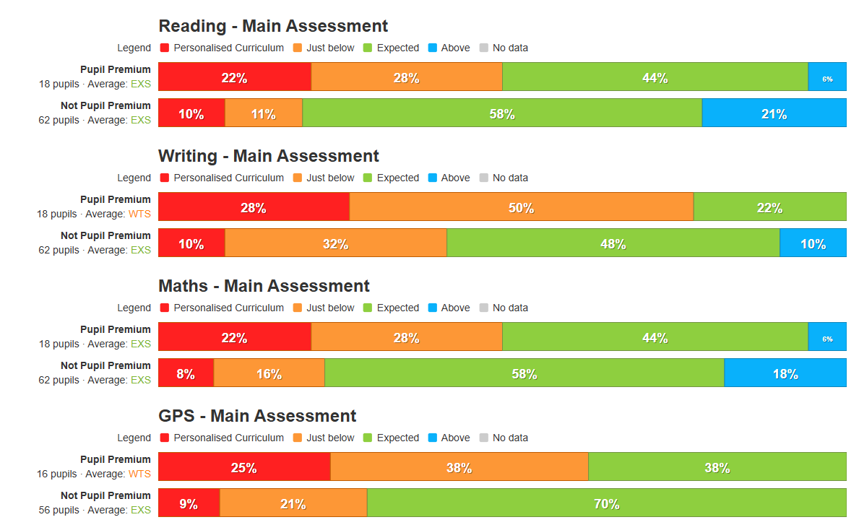
Whole School assessment data shows a significant attainment gap between disadvantaged pupils and their peers across core subjects.
Subject-level analysis indicates similar trends:
- Reading: 44% of disadvantaged pupils met expected standards versus 58% of non-disadvantaged pupils; 6% exceeded expectations compared to 21% of peers.
- Writing: 22% of disadvantaged pupils achieved expected, compared to 58% of their peers gaining expected or higher.
- Maths: 44% of disadvantaged pupils met expected standards compared to 58% of peers; 6% exceeded expectations versus 18% of peers.
- GPS: 38% of disadvantaged pupils met expected standards compared to 70% of peers.
These outcomes were assessed using summative teacher assessments, end of unit assessments and input on our internal tracking system.
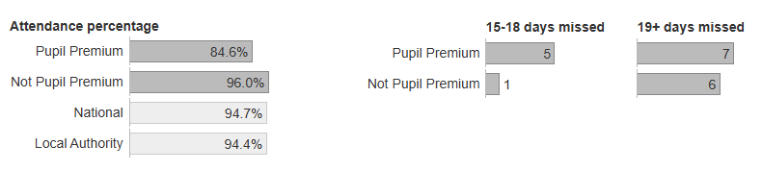
Attendance remains a significant barrier, and this is a direct comparison to the same point last year. Disadvantaged pupils currently average 85% attendance compared to 96% for non-disadvantaged peers, with 32% persistently absent versus 10% of peers—both below national averages. Last year, disadvantaged attendance was slightly higher at 87%, with 5% unauthorised absence and 33% persistent absenteeism.
While overall attendance has declined slightly, it is important to note that persistent absenteeism among disadvantaged pupils has improved from 33% to 32%, despite an increase in the number of disadvantaged pupils on roll this year. Unauthorised absence has also reduced from 7% to 4%, indicating positive impact from interventions, even though attendance overall remains a key priority.
These improvements are supported by targeted strategies: Read Write Inc Phonics (+5 months progress) and Speech and Language Link (+6 months progress) have strengthened early literacy and oral language skills, reducing barriers to engagement; ELSA and EBSA sessions (+4 months progress) have improved emotional wellbeing and reduced anxiety-related absence; and whole-staff behaviour training (+4 months progress) has ensured consistency and a positive climate for learning. Together, these interventions are beginning to address underlying causes of absence and support sustained improvement.
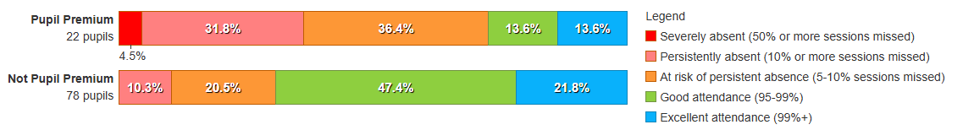
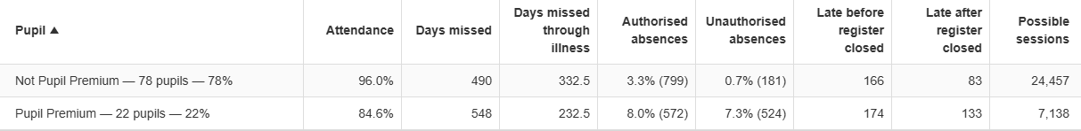
The use of INSIGHT, our new data tracking system, enables leaders to monitor attainment and attendance in real time, identify pupils at risk, and implement timely interventions. According to EEF, improving attendance and engagement alongside targeted academic and wellbeing support is critical for raising attainment. Wider school data highlights attendance and wellbeing as contributing factors, with disadvantaged pupils showing higher rates of absence and emotional needs, which aligns with national trends reported by the DfE and EEF.
Summary of Previous Strategy
The previous strategy had strengths in implementing structured interventions such as phonics (Read Write Inc) and speech and language support, which contributed to progress in writing and reading for some pupils. Staff training in behaviour management also improved consistency across the school. However, attendance and engagement remain key barriers, and gaps in GPS and Reading indicate that interventions need to be more intensive and sustained. The school is not yet on track to fully achieve intended outcomes, and the new strategy will prioritise attendance, targeted academic support, and wellbeing interventions to accelerate progress.

Externally provided programmes
Please include the names of any non-DfE programmes that you used your pupil premium to fund in the previous academic year.
Programme | Provider
Rock and Pop Foundation  1 pupil | Rocksteady
Dancemode
2 pupils
Counselling  1 pupil | Fegans (Spurgeons College)

Further information
Next Steps
To address the gaps we have found, the school will:
- Prioritise attendance by embedding DfE guidance on improving attendance and using INSIGHT to monitor patterns and intervene early.
- Expand mental health and wellbeing support through EBSA (Emotionally Based School Avoidance) and ELSA (Emotional Literacy Support Assistant) sessions delivered by SENCO, targeting pupils with anxiety and emotional needs.
- Utilise the sensory room to provide a calming, regulated environment for pupils who need additional support to manage emotions and re-engage with learning.
- Continue targeted academic interventions in phonics, language development, and small-group tuition, supported by ongoing CPD for staff.
These actions align with EEF recommendations for structured social-emotional learning and targeted support, ensuring disadvantaged pupils receive both academic and wellbeing interventions to improve outcomes.

