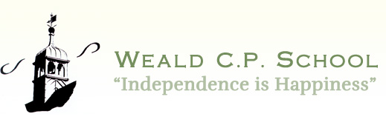
Weald
Primary School
ART Policy
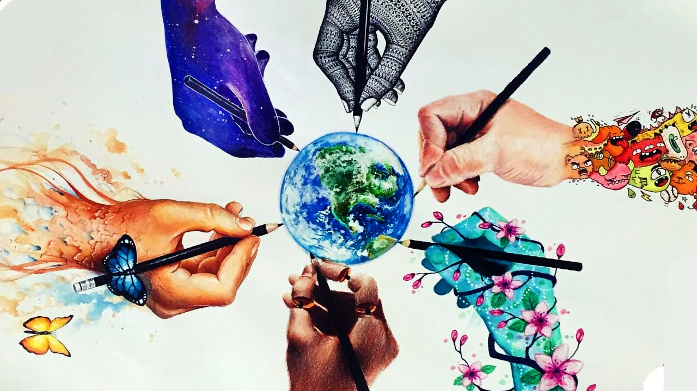

Character Qualities:
Independence to select materials and make decisions using own ideas.
Curiosity to use different materials and techniques.
Self control to use concentration and work collaboratively.

September 2025

ART POLICY
“Creativity is contagious, pass it on”
Albert Einstein
“The arts are like your backbone. You may be able to survive without your backbone but what quality of life would you have?”
Sir Simon Rattle
“Art can show us great things. It’s basically everything”
Pupil voice July 2025
“It’s a way of telling people stuff in a beautiful way”
Pupil voice July 2025
Purpose of Art at Weald
At Weald Primary School, our Art curriculum reflects our shared belief that “we smile, share, and shine together.” Through Art, children learn to express themselves confidently, collaborate generously, and celebrate the diverse ideas and perspectives that make our school community special. We nurture pupils who think for themselves, support one another, and grow into kind, confident individuals—all within a happy, inclusive environment where everyone belongs and everyone matters.
Our vision is to provide a rich, inspiring arts education that encourages every child to explore, experiment, and find joy in creativity. We believe that Art is a powerful language—one that helps children make sense of the world, communicate emotions, and develop imagination. This aligns with Ofsted’s recognition that high-quality Art education enables pupils “to appreciate and interpret what they observe, communicate what they think and feel, or make what they imagine and invent”.
A Curriculum That Builds Skills, Knowledge, and Character
- Our art curriculum is grounded in the National Curriculum, ensuring all pupils develop:
- Practical knowledge—skills such as drawing, painting, sculpture, and mastery of materials.
- Theoretical knowledge—understanding the work of artists, craftspeople, and designers across cultures.
- Disciplinary knowledge—how art is discussed, critiqued, and valued in society.
These domains represent the core structure identified in Ofsted’s Art and Design review, which emphasises the importance of building secure foundations in early years and continuing them through primary education.
We ensure pupils progressively build these skills over time, enabling them to develop the confidence to take creative risks and refine their work—skills also highlighted as essential in Ofsted’s evaluation of effective practice in primary Art.
Creativity at the Heart of Learning
We believe that every child at Weald should have access to high-quality, meaningful creative experiences. This aligns with Ofsted’s recognition that art should hold “an important place in every school” and that rich, diverse art provision enables pupils to thrive intellectually and creatively.

Aims and Intent

Art at Weald Primary School:

Encourages collaboration, celebrating shared ideas and cooperative projects.

Promotes self-expression, building children’s confidence and identity.

Values everyone’s contribution, ensuring all children—regardless of background—feel included, supported, and welcomed.

Fosters joy, curiosity, and creativity, making Art a subject where children look forward to learning and feel proud of their achievements.

This commitment echoes Ofsted’s finding that high-quality art teaching stimulates interest, fuels imagination, and lays secure foundations for future learning from the earliest years onwards.
Our school aims to:

▪ Provide a broad, balanced and exciting arts curriculum which enables motivation, originality and imagination as well as the development of skills.
▪ Develop and raise self-esteem and enhance the standard of arts education across the school.
▪ Enhance the children’s appreciation of different cultures through the arts especially through our joint curriculum project with Kanthenga School, Malawi.
▪ Provide high quality arts experiences and resources for our children.
▪ Develop effective links with the community which strengthen and offer diverse arts provision within the school.
▪ Celebrate the artistic achievements of each child.
▪ Continue to develop the use of ICT and new technologies in creative learning.

National Curriculum Aims

The national curriculum for art and design aims to ensure that all pupils:

• Produce creative work, exploring their ideas and recording their experiences.
• Become proficient in drawing, painting, sculpture and other art, craft and design techniques.
• Evaluate and analyse creative works using the language of art, craft and design
• Know about great artists, craft makers and designers, and understand the historical and cultural development of their art forms.
. Develop an understanding of art itself. This includes areas of thinking such as how art affects our lives, what stories can be told through art and how it can provide perspectives on social, political and moral issues.
.

Implementation: Teaching and Learning
Subject Content

Art, craft and design embody some of the highest forms of human creativity. A high-quality art and design education should engage, inspire and challenge pupils, equipping them with the knowledge and skills to experiment invent and create their own works of art, craft and design. As pupils progress, they should be able to think critically and develop a more rigorous understanding of art and design. They should become increasingly divergent with the practical skills they have learnt and be able to adapt them when producing their own artworks. The pupils should also know how art and design both reflect and shape our history, and contribute to the culture, creativity and wealth of our nation.

Lessons are planned to include the three main domains of artistic knowledge which include learning practical skills alongside theoretical and disciplinary knowledge.

Foundation stage

In the Foundation Stage, the arts are linked throughout all of the planning, so that opportunities arise each day, to be creative. They form part of the Expressive Arts and Design area of learning (see Early Years policy).

Key stage 1 pupils wlll learn to:

- Use a range of materials creatively to design and make products.
- Use drawing, painting and sculpture to develop and share their ideas, experiences and imagination.
- Begin to learn the correct artistic terminology and language of art.
- Develop a wide range of art and design techniques in using colour, pattern, texture, line, shape, form, and space.
- Will learn about the work of a range of artists, craft makers and designers, describing the differences and similarities between different practices and disciplines, and making links to their own work.

Key stage 2 pupils will learn to:

- Develop their techniques, including their control and use of materials, with creativity, experimentation and an increasing awareness of different kinds of art, craft and design.
- Create sketch books to record their observations and use them to review and revisit ideas.
- Improve their mastery of art and design techniques, including drawing, painting and sculpture with a range of materials, for example, pencil, charcoal, paint, clay.
- Build upon the language and terminology of art and creativity.
- Become more divergent with the practical skills they have learnt, using these to develop their own personal styles of art making.
- To appreciate great artists, architects and designers in history.
- Gain a better understanding of how art affects our lives and how it can tell us stories about history and highlight cultural, political and social dilemma.

The aims (detailed above) will be met through the provision of opportunities for all children:

- To continue to develop links with artists and other organisations and broaden interests by being introduced to different artistic experiences.
- To provide a range of resources, materials and skills with which to engage children.
- To be able to develop cross-curricular learning; for example, using a variety of different stimuli for creative writing or to create art which enhances historical knowledge and understanding.
- To celebrate creative thought and outcomes and value every child’s contribution.
- To share creative learning, experiences with our sister school in Malawi
- To use ICT technology to explore and extend creative thought.

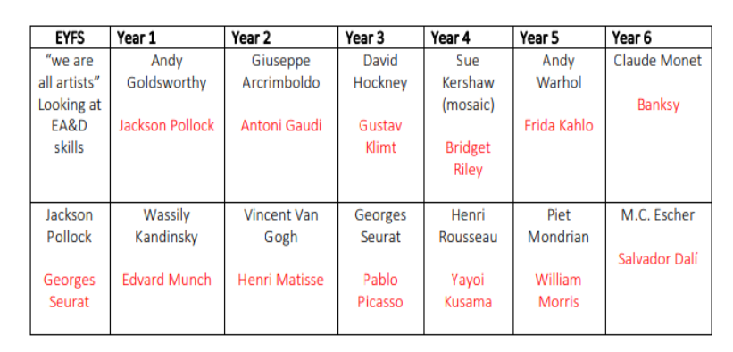
This is an example of some of the focused artists children will be learning about in school. Topics in History and Geography may bring forth other artists which may be studied instead.

Accessible for all

All children regardless of gender, race, culture, background and ability have an entitlement to arts education at an appropriate and challenging level. To ensure that children experience high standards of success, creative development will be taught to take regard of children’s abilities to ensure progress.
Through the arts the children may be encouraged to:

- Be self-motivated and self-critical.
- Value their peers.
- Develop their thinking and reasoning skills.
- Observe, present, evaluate and record experiences.
- Become organised.
- Learn how to use a range of resources to meet their needs.
- Experience diverse and creative teaching and learning styles and make cross curricular links.
- Develop an appreciation and enjoyment of the arts.

Impact: Assessment and Monitoring

Assessment:

Teachers assess art through observation and responding to their work during practical lessons.
Progress is assessed against the learning objectives for their lessons. Pupils are encouraged to assess their own and each other’s work using the vocabulary and skills they have learnt to demonstrate an understanding of their creative development.

Art cannot always be assessed by the final product but through a pupils’ understanding of the techniques used to create art which reflects their personal understanding of what they seek to achieve.

The Role of the subject lead

- Write and review the art policy.
- Monitor teaching and learning.
- Support teachers with resources.
- Attend relevant courses and feedback to staff.
- Seek opportunities to link the school with experienced and emerging artists in the community.

Monitoring and Review:

The subject leader is responsible for coordinating the art curriculum, supporting colleagues with resources and direction and ensuring a broad and balanced range of skills are taught.

Health and Safety:

General requirements for Health and Safety apply in this subject and care needs to be taken when using tools, and materials. Tools should be checked before use, be age appropriate and children should be trained to use them safely. Children are taught to follow proper procedures. Teaching staff are responsible for the supervision of activities.

Character vision
“We are preparing children for the challenges of the 21st century – learning and working in a knowledge making world, rather than a knowledge applying world. Through our creative spirit as teachers, children will heighten their sensitivity, emotional intelligence and resilience and embrace enterprise and risk taking”

Reviewed: September 2025
To be reviewed: July 2026

