Venus - Term 5 Creative Curriculum: What did the Vikings want and how did Alfred help stop them getting it? 2025/2026
Computing:
Creating media – desktop publishing
- Become familiar with the terms ‘text’ and ‘images’ and understand that they can be used to communicate messages.
- Use desktop publishing software and consider careful choices of fontsize, colour and type to edit and improve
documents
  - Learn about ‘templates’, ‘orientation’ and
‘placeholders’ and begin to understand how
these can support making a template for a magazine front cover.
Music:
Bringing Us Together
- Listen and appraise the song Bringing Us Together and other Disco songs
- Learn and/or build on knowledge and understanding about the interrelated dimensions of music
- Perform the song.

R.E:

- What does it mean to be a Christian in Britain today?
- How do family life and festivals show what matters to Jewish people.

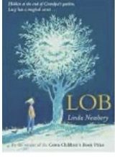
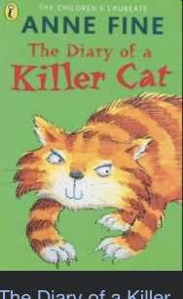
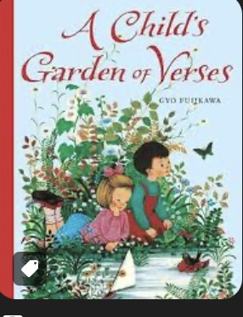
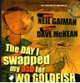
Literacy: Class Reading Book: Lob by Linda Newbery

Non-fiction
Recounts: Diaries and Recounts
Through The Day I Swapped my Dad for Two Goldfish and The Diary of a Killer Cat explore and
write recounts. Study adverbs for time and place and direct speech.
Poetry
Classic Poems: A Child’s Garden of Verses by Robert Louis Stevenson
This wonderful collection loses none of its power to excite, enthuse and inspire
by being immersed in these classic timeless poems. Study verbs, tense and extend sentences.

Science:

- Plants (requirements for life and growth, naming and function of parts)
- Roots and shoots
SPaG:

- Adverbs
- Prepositions
- Conjunctions
- Apostrophes
- Verb tenses
- Direct speech

Topic: History enquiry – What did the Vikings want and how did Alfred help to stop them getting it?

- This investigation aims to help the children distinguish facts from myth, folklore and legend in
relation to the people commonly referred to as ‘the Vikings’, but who never shared or would
have recognised that collective identity.
- The investigation ends with an evaluation of the life and achievements of King Alfred the Great – the only English monarch to be granted the epithet ‘Great’.

Application of skills & processes:
Recognise Identify Describe Empathise Synthesise Explain Apply
Observe Select Categorise Evaluate Reach informed conclusions Hypothesise
Classify Sequence Compare & contrast Make reasoned judgements. Justify
Recall Summarise Reason/speculate Demonstrate understanding Critique

Art/DT:

- The Rainforest: painting and drawing
  Numeracy:  Measurement - Money  - Pounds and pence  - Convert pounds and pence  - Add and subtract money  - Find change  Fractions  - Add and subtract fractions  - Partition the whole  - Unit and non-unit fractions of a set of objects  - Reasoning with fractions of an amount  Mass and capacity  - Use scales  - Measure and compare mass in grams and kilograms  - Add and subtract mass  - Measure capacity and volume in millilitres and litres  - Compare capacity and volume  - Add and subtract capacity and volume |  |  | Numeracy - Reasoning  Reasoning is the catalyst for the teaching of maths. A key skill in becoming fully numerate (and to becoming an independent thinker) is the ability to make your own decisions and learn from them.  This key skill is central to the children’s math’s learning and a chance to allow learners to  choose their own methods and ways of recording,  then present their findings in whichever way they decide. Learners are encouraged to explain their reasoning, thus extending the understanding and their ability to communicate, numerically. | Languages: Spanish  - Months  - Phonics O and AU  - Birthdays | Physical Education:  Athletics:  - Developing skills  Striking and fielding skills:  Cricket: develop skills to field including sending, receiving and retrieving.

